**GNOCCHI WITH ROASTED TOMATO SAUCE**

**Ingredients**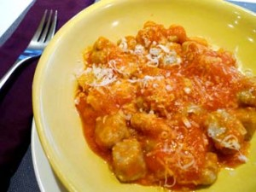

3 russet potatoes  
1/3 cup finely shredded Parmesan cheese  
1 teaspoon salt  
1 pinch pepper  
1 egg  
1 cup flour

**Directions**

1. Bake the potatoes until they are soft (about 45 min) in a 350-degree oven. While still warm, cut in half and, using the skin, push through a sieve or tamis onto a table top.

2. Sprinkle cheese, salt, and pepper over potatoes and cut in with bench scraper. Break egg on top and cut into potato mix until well incorporated.

3. Add flour and cut in until it is fully incorporated. Knead gently until a ball is formed. Flatten dough to about 3/4 inch.

4. Cut dough into 3/4 inch dowels and cut dowels into 1/2-inch pieces. Toss uncooked gnocchi in flour and allow to dry for 15 minutes.

5. Set 6 quarts water, well salted, to boil in large pot.

7. Drop gnocchi into boiling water and cook until they float. Then allow to cook for 2-3 more minutes.

8. Toss with 1/4 cup canola oil and store covered in refrigerator up to 48 hours until ready to serve.

**ROASTED TOMATO SAUCE**

**Ingredients**

5 vine-ripened tomatoes  
1/2 cup extra virgin olive oil, divided  
salt and pepper to taste

**Directions**

1. Set oven to 350F.

2. Cut tomatoes in half lengthwise. Toss with 1/4 cup olive oil and season with salt and pepper. Place in roasting pan and cook 25-30 minutes.

3. Remove tomatoes from oven. Separate skins and discard. Purée tomatoes until smooth. Add 1/4 cup olive oil while blending and add salt and pepper to taste.

from Benjamin Knack, executive chef at the Bedford Village Inn